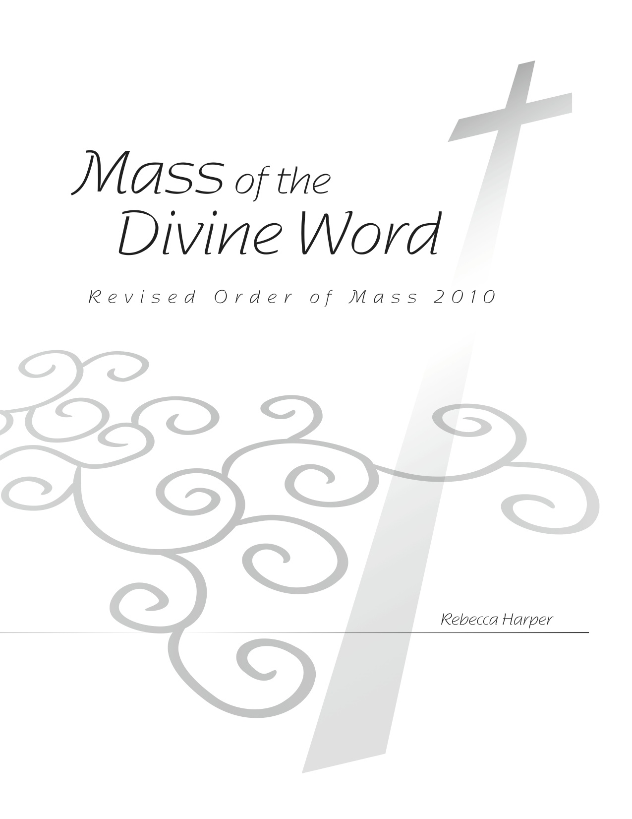

Octavo

Mass of the Divine Word

Kyrie 3

Glory to God 4

Psalm 23, Lord, You Are My Shepherd 8

Gospel Acclamation 9

Nicene Creed 11

Holy Holy Holy 14

Memorial Acclamations 15

Doxology and Amen 16

The Lord’s Prayer 17

Lamb of God 20



